CSCI 3303 Networking Data Communication

Project #1: One to One Network Programming

Due Date: Midnight, Oct. 24, 2021

This project should be a GUI (Graphic User Interface) version of one to one network programming between server and client based on TCP written in Java program language.

**Requirements:**

1. This system consists of server side and client side.

2. ServerSocket class and Socket class in java.net package should be used.

3. Use host name: “localhost” and port number: 2000.

4. Use “quit” as a command to close connection (terminate the system).

Note:

**Sample Run:** 1 to 1 networking project

1. Run server package 🡪 then “connecting ….” message will be popped in dialog box

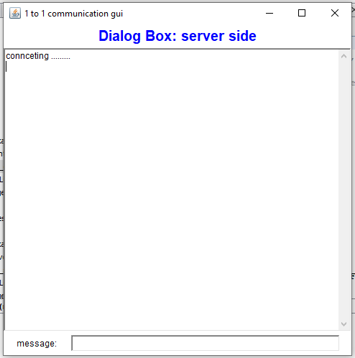

1. Run client package 🡪 then, server and client will be connected and send confirm message each other.

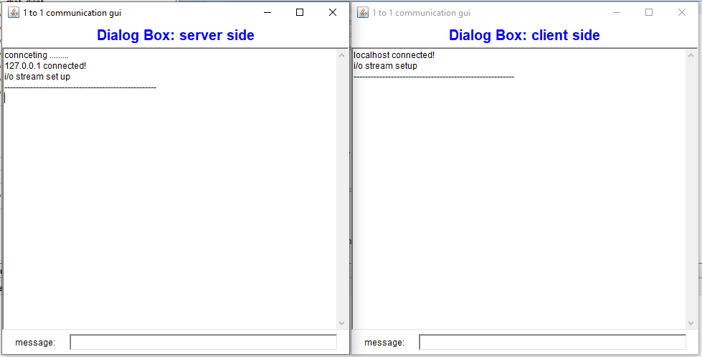

1. Next, client sends message “csci 3303” to server through text box by using enter key in keyboard.

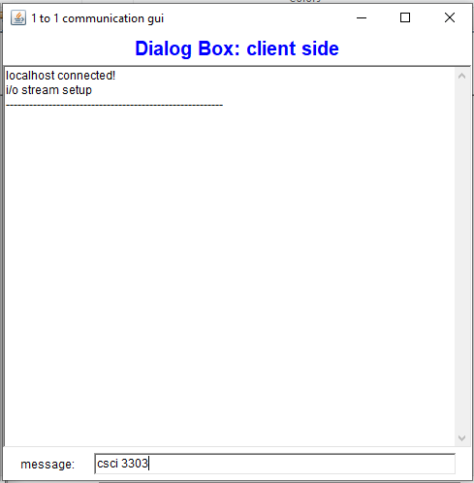

1. Then, it will be popped up in server side dialog box

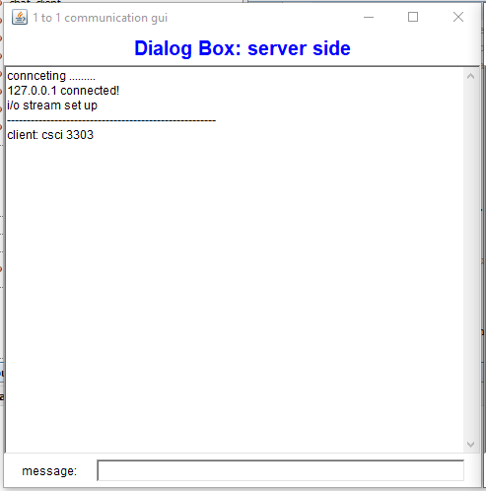

1. Continue to send “computer”, “network” as an message to server one at a time.

Next, reversely, two words ‘great’ and ‘course’ are sent from server to client as well.

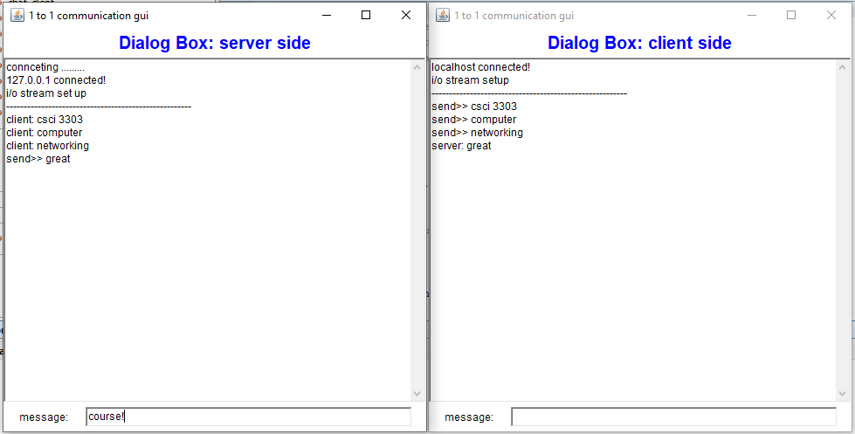

1. Finally, client sends “quit” to server as terminating message 🡪 then close connection both.

